**Kinza Aftab**

**#015**

**BSCS 3**

**Digital logic design**

**8/3/2023**

**Practical 1:**

1: Which gates are categorized as universal gates and how they are used?

Ans: NAND and NOR gates are categorized as universal gates. They can implement any Boolean function without need to use any other gate.

2: Verify the Truth Table for AND Gate and OR Gate.

Ans:

AND gate truth table:

|  |
| --- |
|  |

|  |  |
| --- | --- |
|  |  |
|  |  |

OR gate truth table:

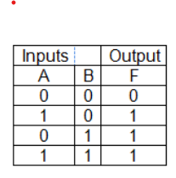

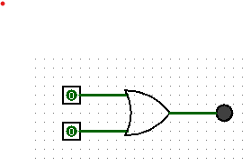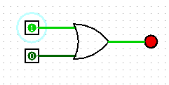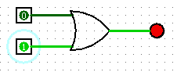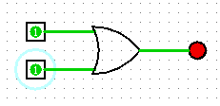

3. Verify the Truth Table for NOR Gate and NAND Gate.

Ans:

Truth table for NOR gate:

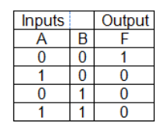

|  |  |
| --- | --- |
|  |  |
|  |  |
| NAND gate truth table: |  |

|  |  |
| --- | --- |
|  |  |
|  |  |

4. Verify the Truth Table for XOR Gate and XNOR Gate.

Truth table for XOR gate:

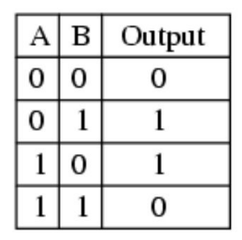

|  |  |
| --- | --- |
|  |  |
|  |  |

Truth table for XNOR gate:

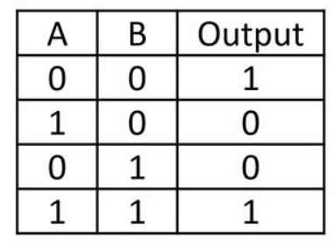

|  |  |
| --- | --- |
|  |  |
|  |  |

5. Convert the following logic gate circuit into a Boolean expression, writing Boolean sub-expressions next to each gate output in the diagram:

Ans: (A+B) * C.

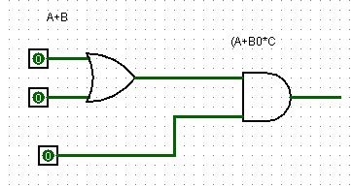

6. Draw the following function in Circuit maker.

i. F = 𝑿̅YZ + 𝑿̅Y𝒁̅ + XZ

|  |
| --- |
|  |

ii. F=𝑿̅Z + X𝒀̅Z +YZ’

|  |
| --- |
|  |